# VISVESVARAYA TECHNOLOGICAL UNIVERSITY



JNANA SANGAMA, BELAGAVI – 590 018

### A Mini Project Report on

JOB PORTAL

*Submitted in partial fulfillment of the requirements as a part of the DBMS Lab for the V Semester of degree of* ***Bachelor of Engineering in Information Science and Engineering*** *of Visvesvaraya Technological University, Belagavi*

### Submitted by

**1RN18IS038-DHAVAL SHREI**

**1RN18IS039-DINKY ASRANI**

**Under the Guidance of**

|  |  |
| --- | --- |
| **Mrs. Anusha**  **Assistant Professor**  **Dept. of ISE, RNSIT** | **Mrs. Kusuma S Assistant Professor**  **Dept. of ISE, RNSIT** |

**Department of Information Science and Engineering**

**RNS Institute of Technology**

Channasandra, Dr. Vishnuvardhan Road, RR Nagar Post, Bengaluru – 560 098

2020 – 2021

# RNS Institute of Technology

Channasandra, Dr.Vishnuvardhan Road, RR Nagar Post, Bengaluru – 560 098

## DEPARTMENT OF INFORMATION SCIENCE & ENGINEERING

CERTIFICATE

This is to certify that the Mini project report entitled ***TITLE OF THE MINIPROJECT IN ITALICS ONLY WITH BOLD*** has been successfully completed by **Dhaval Shree** bearing USN **1RN18is038 and Dinky Asrani** bearing USN **1RN18IS039** , presently V semester student of **RNS Institute of Technology** in partial fulfillment of the requirements as a part of the DBMS Laboratory for the award of the degree ***Bachelor of Engineering in Information Science and Engineering*** under **Visvesvaraya Technological University, Belagavi** during academic year 2020 – 2021. It is certified that all corrections/suggestions indicated for Internal Assessment have been incorporated in the report deposited in the departmental library. The mini project report has been approved as it satisfies the academic requirements as a part of DBMS Laboratory for the said degree.

**Dr./Mr./Mrs. Name Mrs. Kusuma S**

Faculty Incharge Lab Incharge

**Dr. Sathish Kumar K**

Professor and HOD



**External Viva**

**Name of the Examiners Signature with date**

1.

2.

# ABSTRACT

In this competitive era, the education among the people is so increasing that the jobs for them are now decreasing. The companies even want the people who are best in their fields. At that time, it becomes difficult to find the people who are intelligent enough to be hired. The work for the companies also increases to find the people who can fulfill their requirements. Thinking about these problems, one can think about the process which can handle this process and make the work less complex.

This project is about the recruitment process which is done online. The recruitment process here is handled by the system. This project will allow the person to apply for a job in the company for the interested vacancy which would be available at the company. The person will be having the account after registration and will be then called the applied user.

**ACKNOWLEDGMENT**

The fulfillment and rapture that go with the fruitful finishing of any assignment would be inadequate without the specifying the people who made it conceivable, whose steady direction and support delegated the endeavors with success.

I would like to profoundly thank **Management** of **RNS Institute of Technology** for providing such a healthy environment to carry out this Project work.

I would like to express my thanks to our Principal **Dr. M K Venkatesha** for his support and inspired me towards the attainment of knowledge.

I wish to place on record my words of gratitude to **Dr. Sathish Kumar K,** Professor and Head of the Department, Information Science and Engineering, for being the enzyme and master mind behind my Project work.

I would like to express my profound and cordial gratitude to my Lab Incharge **Mrs. Mrs.Kusuma S**, Assistant Professor, Department of Information Science and Engineering for their valuable guidance, constructive comments and continuous encouragement throughout the Project work.

I would like to express my profound and cordial gratitude to my Faculty Incharge **Guide Name** , Assistant Professor, Department of Information Science and Engineering for his/her valuable guidance in preparing Project report.

I would like to thank all other teaching and non-teaching staff of Information Science & Engineering who have directly or indirectly helped me to carry out the project work.

And lastly, I would hereby acknowledge and thank my parents who have been a source of inspiration and also instrumental in carrying out this Project work.

**Dhaval**

**1RN18IS038**

**Dinky**

**1rn18is039**

**TABLE OF CONTENTS**

|  |  |  |
| --- | --- | --- |
| **CERTIFICATE** | | |
| **ABSTRACT** | | **i** |
| **ACKNOWLEDGMENT** | | **ii** |
| **TABLE OF CONTENTS** | | **iii** |
| **LIST OF FIGURES** | | **v** |
| **ABBREVATIONS** | | **vi** |
| **1. INTRODUCTION** | | **1** |
| 1.1 Background | | |
| 1.2 Introduction about the project | | |
| 1. **E R DIAGRAM AND RELATIONAL SCHEMA DIAGRAM**    1. Description of ER Diagram    2. Description of Relational Schema Diagram | | |
| **3. SYSTEM DESIGN** | | **6** |
| 4.1 | Tables Description | 6 |
| * 1. Normalization of Tables   2. Stored Procedure and Triggers   **4. IMPLEMENTATION** | | |
| 5.1 | Front end and Back end used | 12 |
| 5.2 | Discussion of code segments | 14 |
| 5.3 | Applications of project Work | 20 |
| 5.4 | Discussion of the Results | 22 |
| **5. CONCLUSION AND FUTURE ENHANCEMENTS** | | **27** |
| **REFERENCES** | | 30 |

# ABBREVIATIONS

|  |  |  |
| --- | --- | --- |
| BOOTP | - | Bootstrap Protocol |
| BGP | - | Border Gateway Protocol |
| CMC | - | C Model Checker |
| DNS | - | Domain Name Service |
| DHCP | - | Dynamic Host Control Protocol |
| DART | - | Directed Automated Random Testing |
| D3S | - | Debugging Deployed Distributed Systems |
| DNSSD | - | DNS Service Discovery |
| D-ITG | - | Distributed Internet Traffic Generator |
| DNV | - | Declarative Network Verifier |
| IETF | - | Internet Engineering Task Force |
| IOT | - | Interoperability Testing |
| LLVM | - | Low Level Virtual Machine |
| MPE-SE | - | Multiple Packet Exchange – Symbolic Execution |
| PPP | - | Pont-to-Point Protocol |
| PC | - | Path Condition |
| RFC | - | Request for Comments |
| SAGE | - | Scalable, Automated Guided Execution |
| SM | - | Symbolic Map |
| SPE-SE | - | Single Packet Exchange – Symbolic Execution |
| TRAM | - | Tree Based Reliable Mulicast |
| mDNS | - | MulicastDNS |

vi

**Chapter 1**

**INTRODUCTION**

* 1. **Background**

A database is an organized collection of data, generally stored and accessed electronically from a computer system. Where databases are more complex they are often developed using formal design and modeling techniques. The database management system (DBMS) is the software that interacts with end users, applications, the database itself to capture and analyze the data and provides facilities to administer the database. The sum total of the database, the DBMS and the associated applications can be referred to as a "database system". Often the term "database" is also used to loosely refer to any of the DBMS, the database system or an application associated with the database. The DBMS manages three important things: the data, the database engine that allows data to be accessed, locked and modified and the database schema, which defines the database’s logical structure. These three foundational elements help provide concurrency, security, data integrity and uniform administration procedures. Typical database administration tasks supported by the DBMS include change management, performance monitoring/tuning and backup and recovery. Many database management systems are also responsible for automated rollbacks, restarts and recovery as well as the logging and auditing of activity.

* 1. **Introduction to Job vacancy management system:**

Online Job Portal is a PHP, MySQL based project, demonstrating the functionalities required to run a job portal. With the advent of internet applying for jobs and getting a placement has become a hassle free task. A job seeker can view thousands of jobs posted by employers and can apply for a job suiting his skills. Job Portal enables an employer can post a job and can view information of enrolled job seekers. An Employer can view and download the resume of applicants. Online job portal project is made up of 3 modules namely Admin, Employer and Job Seeker.



**Chapter 2**

**E R DIAGRAM AND RELATIONAL SCHEMA DIAGRAM**

**2.1 Description of ER Diagram**

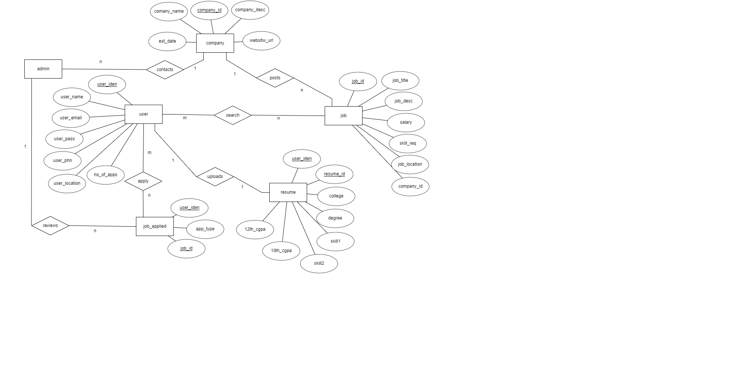

Figure 2.1: E-R Diagram for Job Vacancy Management System

Entity relationship diagram displays the relationships of entity set stored in a database. In other words, we can say that ER diagrams help you to explain the logical structure of databases. At first look, an ER diagram looks very similar to the flowchart. However, ER Diagram includes many specialized symbols, and its meanings make this model unique.

18CSL58: DBMS LAB WITH MINI PROJECT

**2.1.1 Components of job vacancy management system, E-R Diagram**

Entity types like JOB and JOB_SEEKER are in rectangular boxes.

1. Relationships like UPLOAD and HAS are in diamond boxes, attached to entity types with straight lines.

2. Attributes are shown in ovals like USER_NAME and USER_NAME, each attached by a straight line to entity or relationship type.

3. Key attributes like JOB_ID are underlined.

**2.1.2 E-R Diagram Relationships Description**

**COMPANY:JOB** is of cardinality 1:N as one company can have more than one job and therefore connected by an IN relationship.

**COMPANY:ADMIN** is of cardinality 1:N as admin can contact to all the companies.

**ADMIN:JOB**_APPLIED is of cardinality 1:N as there can be more than one job applied.

**USER:JOB** is of cardinality M:N as a user can search for more than one job and a job could be searched by any number of users.

**ADMIN:JOB**_APPLIED is of cardinality 1:N as admin will review all the jobs applied.

**USER:JOB_APPLIED** is of cardinality M:N as a user can apply for more than one job and there could be more than one users who have applied for the same job.

**USER:RESUME** is of cardinality 1:1 as one user can upload his resume once.

**2.2 Description of Relational Schema Diagram**

**USER**

|  |  |  |  |  |  |  |
| --- | --- | --- | --- | --- | --- | --- |
| User_idene | User_name | User_pass | User_age | User_phn | User_location | No_of_apps |

**JOB**

|  |  |  |  |  |  |  |
| --- | --- | --- | --- | --- | --- | --- |
| Job_id | Job_title | Job_description | Job_location | salary | Skills_required | Company_id |

**COMPANY**

|  |  |  |  |  |
| --- | --- | --- | --- | --- |
| Company_id | Company_name | Company_desc | Est_date | Website_url |

**JOB_APPLIED**

|  |  |  |
| --- | --- | --- |
| User_iden | Job_id | App_type |

**RESUME**

|  |  |  |  |  |  |  |  |
| --- | --- | --- | --- | --- | --- | --- | --- |
| Resume_id | User_iden | college | degree | Skill1 | Skill2 | 10th_cgpa | 12th_cgpa |



**2.2.1 General Constraints**

**1. NULL Constraint**:

Attributes that are under NOT NULL constraints have to be filled compulsorily. Almost all the attributes in the project are under NOT NULL constraint.

**2. Entity Integrity Constraint**:

This constraint makes sure that no primary key can have a NULL value assigned to it. The primary keys involved in the project include:

• user_id

• job_id

• company_id

• resume_id

1. **Referential Integrity Constraints:**

A table in the back end of the project may have references pointing to an attribute in another table. For example: user_id in the job_applied table refers to user_id in user table. The various tables are also linked with multiple foreign keys which are all set to cascade any update or delete operation on the attribute in the main table. The various Foreign Key attributes are:

• job_id

• user_id

**2.2.2 Schema Description**

The above Figure.2.2 shows the relational schema of Job Vaccancy Management System. It has the following entities.

**1. USER**: This table contains the details like user name, id, age. User_id is the primary key.

**2. JOB**: This table contains job details such as job_id, description.

**3. RESUME**: This table consists of all the user details like college name, skills.

**4. COMPANY**: This table consists of company details like company name, establishment date, company’s website url.

**5. JOB_APPLIED**: This table consists of user_id which is referential integrity constant and app_type which is description of why the person needs the job.

**Chapter 3**

**SYSTEM DESIGN**

**3.1 Table Description**

**1-USER**

|  |  |  |  |  |
| --- | --- | --- | --- | --- |
| FIELD | TYPE | NULL | KEY | DEFAULT |
| User_iden | Varchar(10) | No | primary | None |
| User_name | Varchar(25) | No |  | None |
| User_pass | Varchar(20) | No |  | None |
| User_email | Integer | No |  | None |
| User_phn | integer | No |  | None |
| User_location | Varchar(20) | No |  | None |

**2-JOB**

|  |  |  |  |  |
| --- | --- | --- | --- | --- |
| FIELD | TYPE | NULL | KEY | DEFAULT |
| job_id | Varchar(10) | No | primary | None |
| job_title | Varchar(20) | No |  | None |
| Job_description | Varchar(45) | No |  | None |
| Job_location | Varchar(20) | No |  | None |
| salary | Integer | No |  | None |
| Skills_required | Varchar(25) | No |  | None |
| Company_id | integer | No | foreign | None |

department of ISE, 2017-2018 2

**3-COMPANY**

|  |  |  |  |  |
| --- | --- | --- | --- | --- |
| FIELD | TYPE | NULL | KEY | DEFAULT |
| COMPANY_ID | Varchar(10) | No | primary | None |
| COMPANY_NAME | Varchar(20) | No |  | None |
| COMPANY_DESC | Varchar(45) | No |  | None |
| EST_DATE | Varchar(20) | No |  | None |
| WEBSITE_URL | Varchar(45) | No |  | None |

**4-JOB_APPLIED**

|  |  |  |  |  |
| --- | --- | --- | --- | --- |
| FIELD | TYPE | NULL | KEY | DEFAULT |
| User_iden | Varchar(10) | No | Foreign | None |
| Job_id | Varchar(10) | No | foreign | None |
| App_type | Varchar(10) | no |  | None |

**5-RESUME**

|  |  |  |  |  |
| --- | --- | --- | --- | --- |
| FIELD | TYPE | NULL | KEY | DEFAULT |
| Resume_id | Varchar(10) | None |  | None |
| User_iden | Varchar(10) | None | foreign | None |
| College | Varchar(45) | None |  | None |
| Degree | Varchar(10) | None |  | None |
| Skill1 | Varchar(20) | None |  | None |
| Skill2 | Varchar(20) | None |  | None |
| 10th_cgpa | decimal(3,2) | None |  | None |
| 12th_cgpa | Decimal(3,2) | None |  | None |

**3.2 Stored Procedures**

A **stored procedure** is a set of Structured Query Language (SQL) statements with an assigned name, which are **stored** in a relational database management system as a group, so it can be reused and shared by multiple programs.

In our project, the stored procedure displays the jobs under a particular skill and lists the details of those jobs. The user searches using the skill required for the job.

CREATE PROCEDURE ‘searchskill’ (IN ‘skill’ VARCHAR(25))

Begin

Select * from job

Where skill_req=skill;

end

**3.3 Trigger**

A trigger is a stored procedure in database which automatically invokes whenever a special event in the database occurs. For example, a trigger can be invoked when a row is inserted into a specified table or when certain table columns are being updated.

In our project trigger is used to increment the number of job applications a user has made, whenever the user applies for a new job.

CREATE TRIGGER increment_job_no

AFTER insert

On job_applied

BEGIN

UPDATE user

Set no_of_apps=no_of_apps+1;

Where user_iden=new.user_iden;

END

**Chapter 4**

**IMPLEMENTATION**

**4.1 Front-end Development**

The front-end is built using a combination of technologies such as Hypertext Markup Language (HTML), JavaScript and Cascading Style Sheets (CSS). Front-end developers design and construct the user experience elements on the web page or app including buttons, menus, pages, links, graphics and more.

**4.1.1 Hypertext Markup Language**

HTML is a computer language devised to allow website creation. These websites can then be viewed by anyone else connected to the Internet. It is relatively easy to learn, with the basics being accessible to most people in one sitting; and quite powerful in what it allows you to create. HTML is the standard markup language for creating Web pages. It stands for Hyper Text Markup Language. It describes the structure of a Web page. It consists of a series of elements. It elements tell the browser how to display the content. It elements are represented by tags. HTML tags label pieces of content such as "heading", "paragraph", "table", and so on. Browsers do not display the HTML tags, but use them to render the content of the page.

**4.1.2 Cascading style sheets**

CSS stands for Cascading Style Sheets. It is a style sheet language which is used to describe the look and formatting of a document written in markup language. It provides an additional feature to HTML. It is generally used with HTML to change the style of web pages and user interfaces. CSS is used along with HTML and JavaScript in most websites to create user interfaces for web applications. Before CSS, tags like font, color, background style, element alignments, border and size had to be repeated on every web page. This was a very long process. CSS solved that issue. CSS style definitions are saved in external CSS files so it is possible to change the entire website by changing just one file. CSS provides more detailed attributes than plain HTML to define the look and feel of the website.

**4.1.3 JavaScript**

JavaScript is a dynamic computer programming language. It is lightweight and most commonly used as a part of web pages, whose implementations allow client-side script to interact with the user and make dynamic pages. It is an interpreted programming language with object-oriented capabilities. Client-side JavaScript is the most common form of the language. The script should be included in or referenced by an HTML document for the code to be interpreted by the browser. It means that a web page need not be a static HTML, but can include programs that interact with the user, control the browser, and dynamically create HTML content. The JavaScript client-side mechanism provides many advantages over traditional CGI server-side scripts. The JavaScript code is executed when the user submits the form, and only if all the entries are valid, they would be submitted to the Web Server. JavaScript can be used to trap user-initiated events such as button clicks, link navigation, and other actions that the user initiates explicitly or implicitly. Advantages are: Less server interaction, immediate feedback to the visitors, increased interactivity and richer interfaces.

**4.2 Back-end Development**

Backend is server side of the website. It stores and arranges data, and also makes sure everything on the client-side of the website works fine. It is the part of the website that you cannot see and interact with. It is the portion of software that does not come in direct contact with the users. The parts and characteristics developed by backend designers are indirectly accessed by users through a front-end application. Activities, like writing APIs, creating libraries, and working with system components without user interfaces or even systems of scientific programming, are also included in the backend.

**4.2.1 Backend scripting language**

PHP Hypertext Preprocessor PHP is used as the server side scripting language. PHP is an acronym for "PHP: Hypertext Preprocessor". PHP is a widely-used, open source scripting language. PHP scripts are executed on the server. It is compatible with all servers used today. It is easy to use and runs efficiently on the server side. It can run on various platforms like windows, Linux, UNIX, Mac OS-X etc. and since it is a scripting language, it comes with predefined functions which makes it easy to implement any logic necessary.

**4.2.2 Web Server**

Apache is an open-source and free web server software that powers around 46% of websites around the world. The official name is Apache HTTP Server, and it’s maintained and developed by the Apache Software Foundation. It allows website owners to serve content on the web — hence the name “web server”. Although we call Apache a web server, it is not a physical server, but rather a software that runs on a server. Its job is to establish a connection between a server and the browsers of website visitors (Firefox, Google Chrome, Safari, etc.) while delivering files back and forth between them (client-server structure). Apache is a cross-platform software, therefore it works on both UNIX and Windows servers.

**4.2.3 Database**

MySQL is a fast, easy-to-use RDBMS being used for many small and big businesses. It is developed, marketed and supported by MySQL AB, which is a Swedish company. It is released under an open-source license. So you have nothing to pay to use it. It is a very powerful program in its own right. It handles a large subset of the functionality of the most expensive and powerful database packages. It uses a standard form of the well-known SQL data language. It works on many operating systems and with many languages including PHP, PERL, C, C++, JAVA, etc. It works very quickly and works well even with large data sets. It is very friendly to PHP, the most appreciated language for web development. MySQL supports large databases, up to 50 million rows or more in a table. The default file size limit for a table is 4GB, but you can increase this (if your operating system can handle it) to a theoretical limit of 8 million terabytes (TB). It is customizable. The open-source GPL license allows programmers to modify the MySQL software to fit their own specific environments.

* 1. **User flow diagram**

View company details

Apply for job

Search for job

Upload resume

login

home

Sign up

**4.4 Discussion of Results**

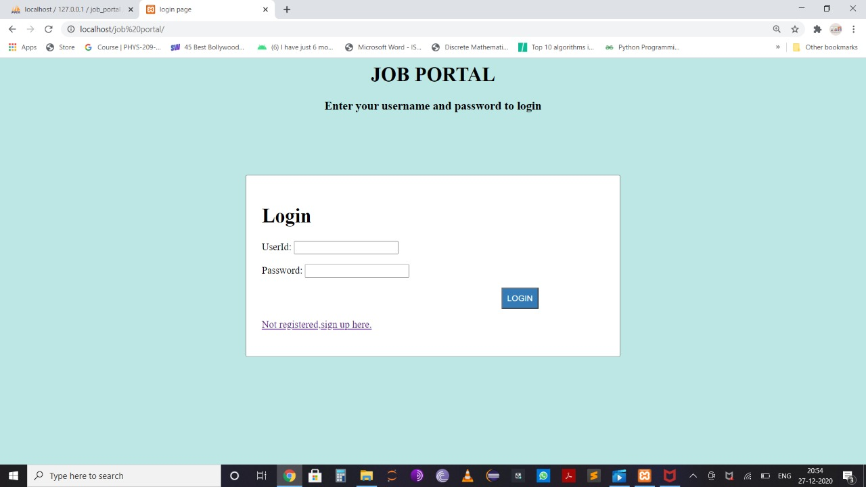

This is the login page of our project, if you are not an existing user you can sign up for the portal. The above Figure is the snapshot of the homepage with the login prompt. If the user has already registered with the website, he can login using his email ID or username which he used to register along with the valid password also which he set during sign up.

If a new user wants to register with the website, he can use this form to register. It accepts the username, email ID, password, and his contact details like phone number and address.

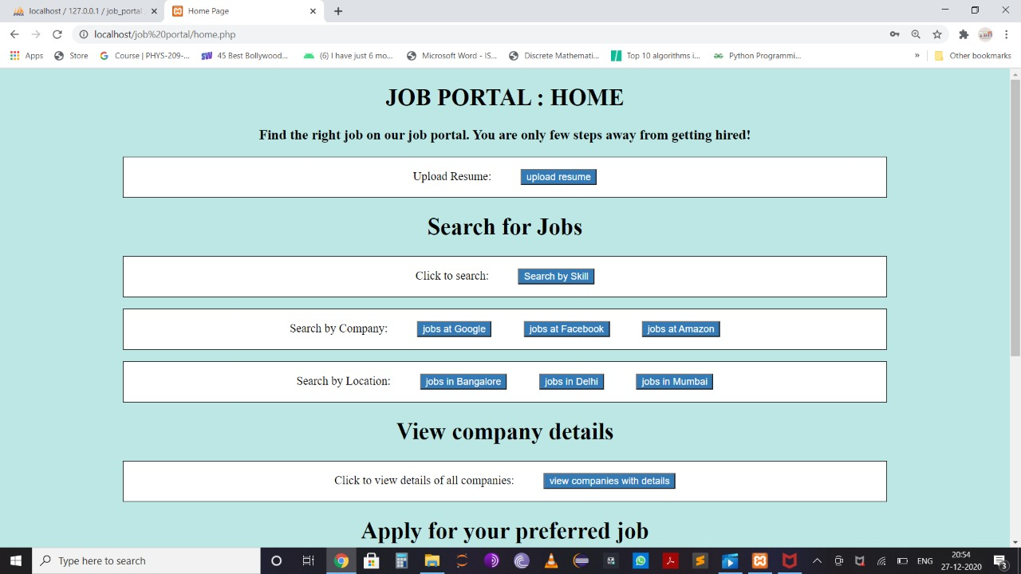

The above figure is snapshot of our home page. The user can upload resume here, search for jobs and apply for the same.

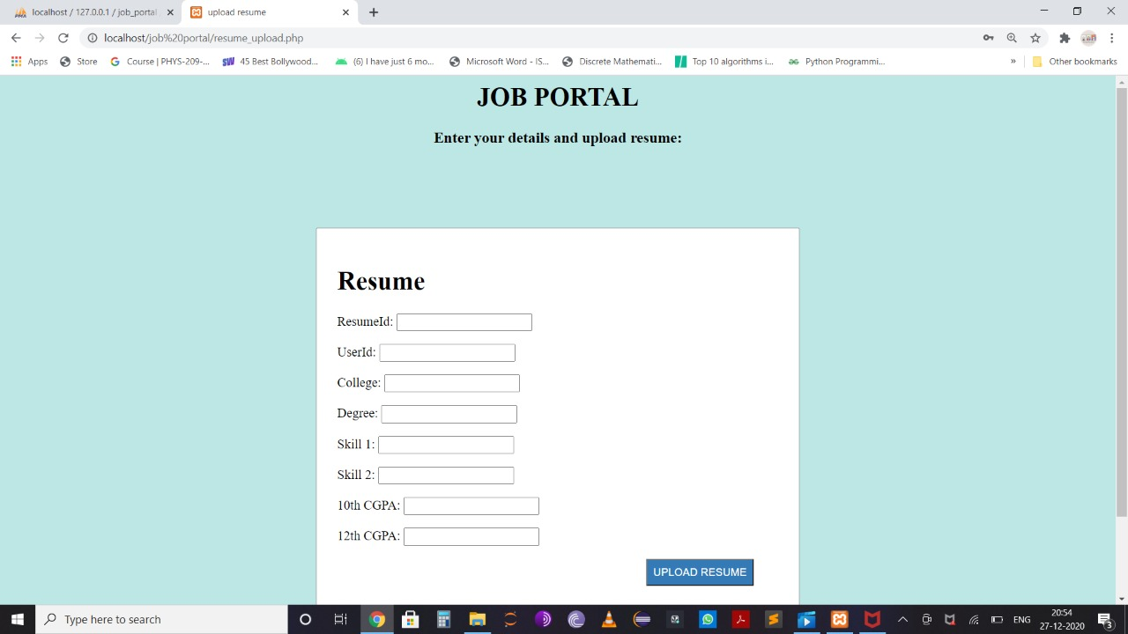

The above figure is snapshot of the form to upload resume.

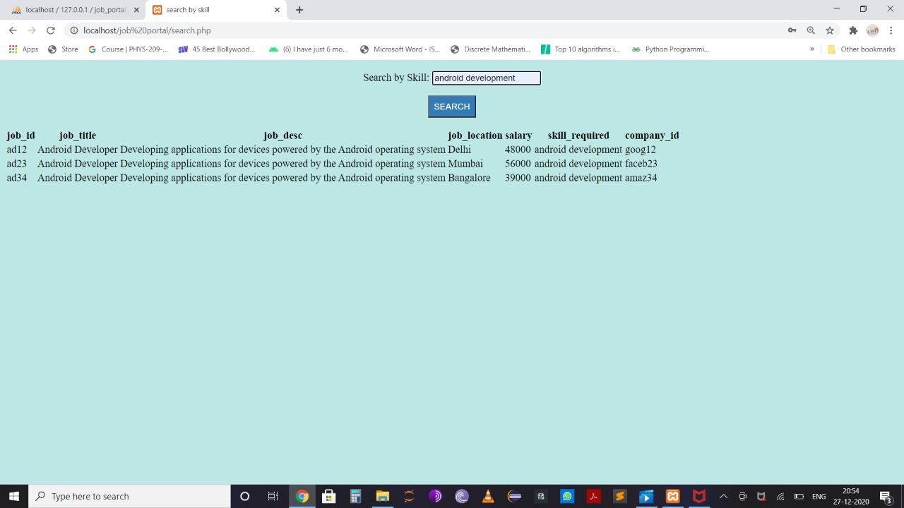

The above figure shows a form to search jobs by skills. The user is supposed to enter the skill which he prefers and corresponding jobs are displayed.

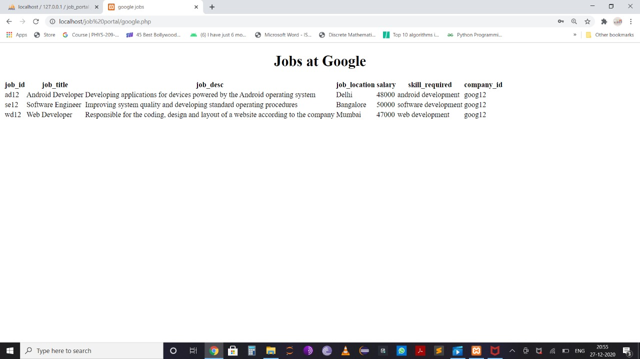

The above figure shows the page when the button to search jobs by company is clicked.

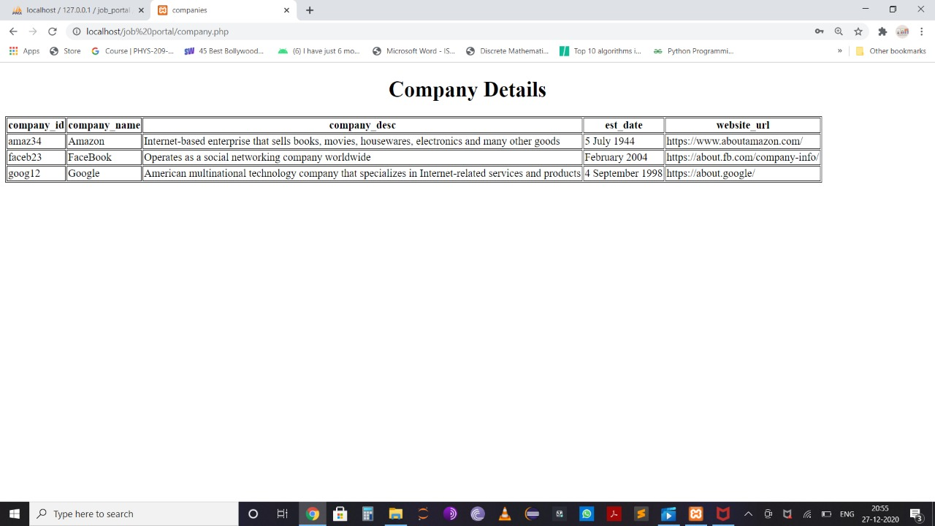

The above figure shows the company details. The user can view the company details by clicking the corresponding button on home page.

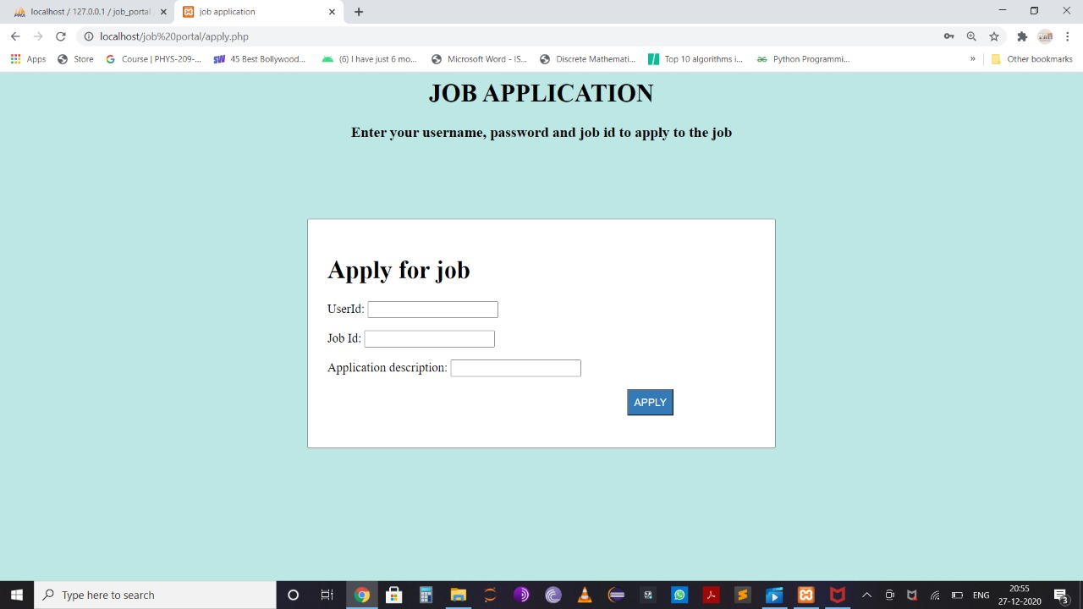

The above figure is the snapshot of the form where user can apply for jobs by providing the job_id

Of the job he wants to apply.

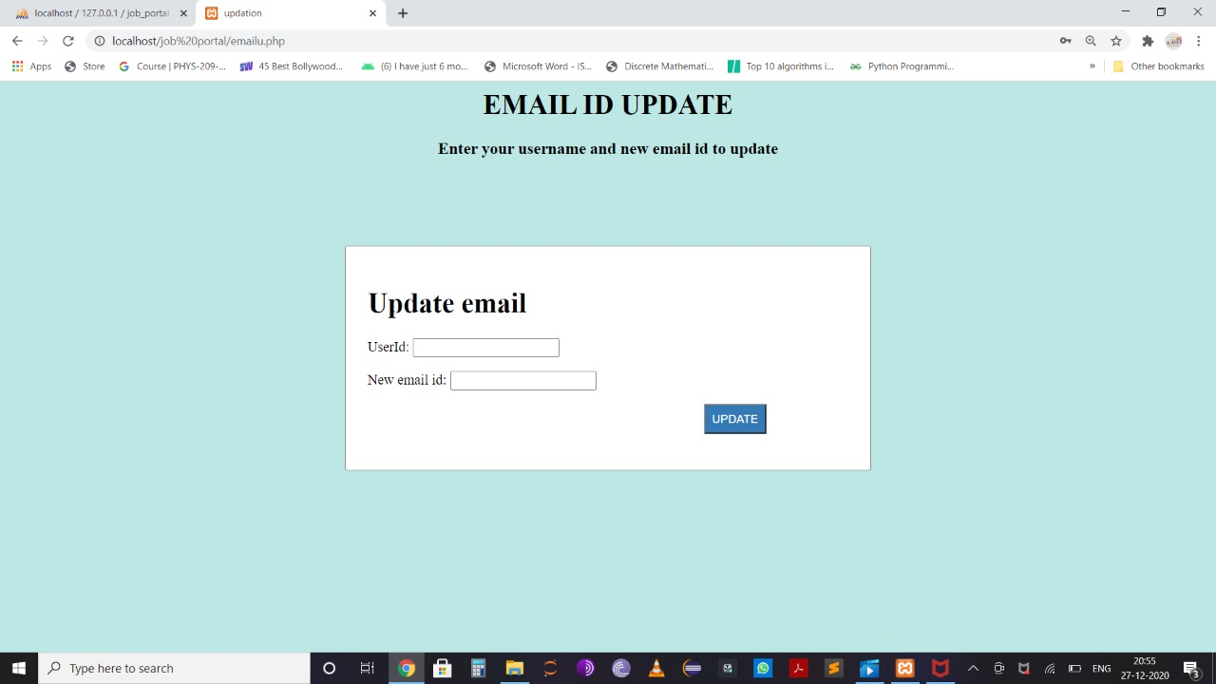

The above figure is the snapshot of the form where user can update his email id and similarly the other contact details.

**Chapter 5**

**CONCLUSION AND FUTURE ENHANCEMENT**

**5.1 Conclusion**

This project was an attempt to make the structure and working of online job portal system simpler and user-friendly. This was an attempt to make it similar to the real world implementation. In this scenario, all the undertakings of the Job vacancy Management System was achieved in a constructive manner. Given the right guidance and support its applications and availability can be enhanced.

**5.2 Future Enhancements**

We can provide a company login where the company can directly upload/delete jobs without contacting the admin.